Restaurant management system

By:
M. Danial
Musa bin Abdullah
Abdullah Altaf

Contents
1 Chapter 1: Introduction 3
1.1 BACKGROUND 3
1.2 Entities 4
2 Chapter 2: Design 7
3 Chapter 3: Relationship 8
4 Chapter 4: inclusion and exclusion 9

Title
Restaurant Management System

PREFACE:
This project involves designing a food selling system using a database on SQL. As the evolution and modernization of the world, food selling is also revolutionized from a stall to a place selling. With this system, you can keep a record of your items selling, taxes and profits easily. The database includes components like separate tables(entities)for Customers, Menu, Order, Order-Status, Reservations, Staffs (Waiter), beverages, food items.

Chapter 1: Introduction

BACKGROUND

Restaurant Management Systems:
The origin of restaurant management systems can be traced back to the 1970s and 1980s, when restaurants began using basic computer systems to manage orders, inventory, and customer data. However, the modern concept of restaurant management systems as we know it today began to take shape in the 1990s and 2000s with the advent of:
Some notable milestones in the evolution of restaurant management systems include:

- 1973: The first restaurant POS system, called "Restaurants Unlimited," was developed.
- 1985: The first inventory management software for restaurants, called "Food Trak," was released.
- 1995: The first web-based restaurant management system, called "Restaurant Plus," was launched.
- 2005: The first cloud-based restaurant management system, called "Breadcrumb," was introduced.

Entities
1.Customer
CustomerID: INT (Primary Key)
FirstName: VARCHAR(50)
LastName: VARCHAR(50)
PhoneNumber: VARCHAR(15)
2. MenuItems
Menu_ID: INT (Primary Key)
Name: VARCHAR(100)
Description: TEXT
Price: DECIMAL(10, 2)
CategoryID: INT (Foreign Key to Categories)
3. Categories
CategoryID: INT (Primary Key)
CategoryName: VARCHAR(50)
4. Orders
OrderID: INT (Primary Key)
CustomerID: INT (Foreign Key to Customers)
TotalAmount: DECIMAL(10, 2)
StatusID: INT (Foreign Key to OrderStatus)
StaffID: INT (Foreign Key to Staff)
5. OrderDetails
OrderDetailID: INT (Primary Key)
OrderID: INT (Foreign Key to Orders)
MenuItemID: INT (Foreign Key to MenuItems)
Quantity: INT
Price: DECIMAL(10, 2)
6. Staff
StaffID: INT (Primary Key)
FirstName: VARCHAR(50)
LastName: VARCHAR(50)
RoleID: INT (Foreign Key to Roles)
HireDate: DATE
PhoneNumber: VARCHAR(15)
7. Roles
RoleID: INT (Primary Key)
RoleName: VARCHAR(50)
8. Reservations
ReservationID: INT (Primary Key)
CustomerID: INT (Foreign Key to Customers)
ReservationDate: TIMESTAMP
NumOfGuests: INT
TableNumber: INT
9. Inventory
InventoryID: INT (Primary Key)
ItemName: VARCHAR(100)
Quantity: INT
Unit: VARCHAR(50)
LastUpdated: TIMESTAMP (Default: CURRENT_TIMESTAMP)
StaffID: INT (Foreign Key to Staff)
10. OrderStatus
StatusID: INT (Primary Key)
StatusName: VARCHAR(50)

Chapter 2: Design

The design is shown in the figure below.

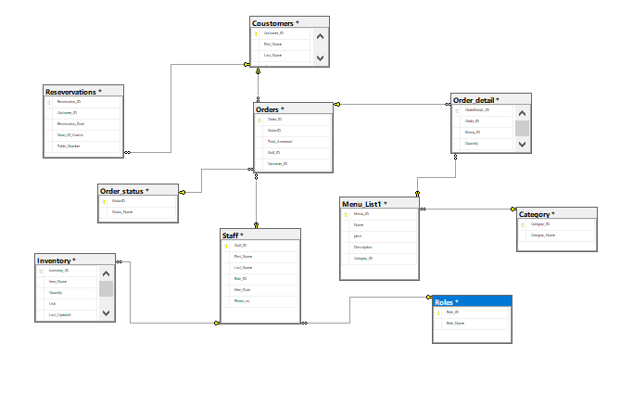

Relationship Diagram

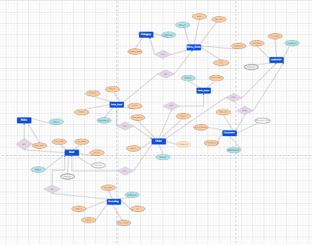

E-R Diagram

Chapter 3: Relationship

- Customers (1) to Orders (Many): One customer can place many orders.
- Customers (1) to Reservations (Many): One customer can make many reservations.
- Categories (1) to Menu Items (Many): One category can have many menu items.
- Orders (1) to Order Details (Many): One order can have many order details.
- Menu Items (1) to Order Details (Many): One menu item can be part of many order details.
- Order Status (1) to Orders (Many): One order status can be associated with many orders.
- Staff (1) to Orders (Many): One staff member can handle many orders.
- Roles (1) to Staff (Many): One role can be assigned to many staff members.
- Staff (1) to Inventory (Many): One staff member can update many inventory items.

Chapter 4: inclusion and exclusion
- Inclusions:
- Customer Entity:
  - Includes attributes such as CustomerID, FirstName, LastName, PhoneNumber, allowing the system to store customer information.
- MenuItems Entity:
  - Stores menu items along with their descriptions, prices, and category information.
- Categories Entity:
  - Provides a way to categorize menu items.
- Orders Entity:
  - Represents orders placed by customers, including total amount, customer ID, and order status.
- OrderDetails Entity:
  - Contains details of each item ordered in an order, such as quantity, price, and reference to the menu item.
- Staff Entity:
  - Stores information about staff members, including their roles, hire dates, and contact details.
- Roles Entity:
  - Defines different roles that staff members can have within the system.
- Reservations Entity:
  - Keeps track of reservations made by customers, including reservation date, number of guests, and table number.
- Inventory Entity:
  - Manages inventory items, including quantity, unit, and last updated information.
- OrderStatus Entity:
  - Defines various statuses that an order can have.
- Exclusions:
- Payment Information:
  - The schema does not include entities or attributes related to payment information, such as payment method, transaction ID, or payment status.
- Address Information:
  - There's no provision for storing address information for customers or staff members.
- Promotions or Discounts:
  - There are no entities or attributes related to promotions, discounts, or coupons that could be applied to orders or menu items.
- Feedback or Reviews:
  - There's no structure to capture customer feedback or reviews about menu items, staff service, or overall experience.
- Ingredient Details:
  - The schema doesn't include information about individual ingredients used in menu items or their quantities.
- Analytics or Reporting Data:
  - There's no provision for storing analytics or reporting data related to sales, inventory management, or customer behavior.

